Councillor Nigel Foot
Mayor of Newbury
2023 – 2024

Official Record of Year in Office
14th May 2023 – 12th May 2024

Date of Mayor Making: 14th May 2023

Deputy Mayor: Cllr Andy Moore
Mayoress: Cllr Sarah Slack
Chaplain: Revd. Will Hunter Smart
Cadets: Able Cadet Alisdair Shankland
Able Cadet Patrick Whitehead
Civic Manager: Elisa Mullen
Virginia Robins (Maternity Cover)
Corporate Support: Amy Xing
Chief Executive: Hugh Peacocke
Toby Miles-Mallowan

Civic Staff
Mayor’s Attendant – Ian Campbell
Town Crier – Brian Sylvester
Town Marshal – Barry Digby
Mace Bearer – Garry Poulson
Mace Bearer – Anthony Hewitt
Keeper of the Robes – Joyce Lewis

Mayor’s Chosen Charity
West Berkshire Homeless
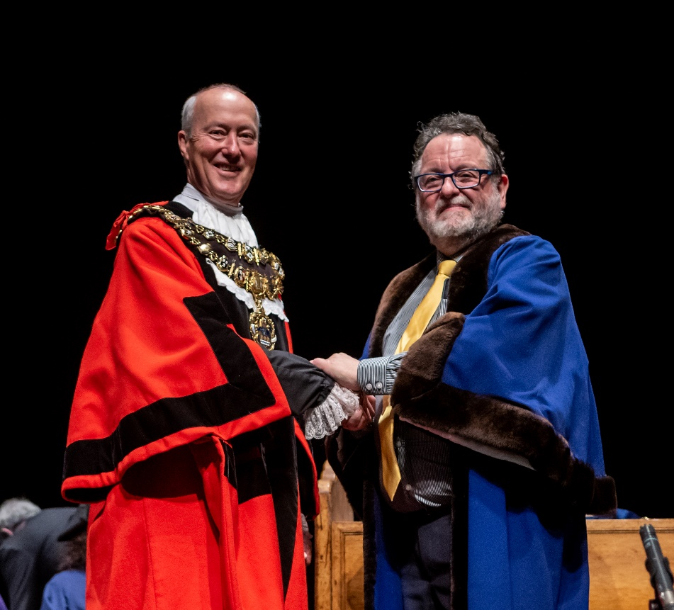
A Taste of the Civic Year 2023 / 2024
Not long into my year as Mayor, it occurred to me that, at last, our community and many of our voluntary organisations in Newbury were fully back to pre-Covid 19 levels of activity. My feeling was that it had taken quite a while for many organisations, that rely on volunteers organising and running everything, to return to inviting the Mayor to open events and to come along to join in celebrations.

My second realisation was how much the voluntary sector does for our community and how indebted we, as a community are, to all those volunteers.

I am proud of what an inclusive and diverse community we are in Newbury. As Mayor, it has been my privilege to attend the opening of a Lithuanian school, Ukrainian poetry and cultural events, visit the two mosques in our region to celebrate Eid and attend Iftar events. As Mayor, I represented the Town at the solemn Holocaust Memorial Day event held at West Berkshire Council, as well as attending the Christmas Carol Service at St Nicolas’s Church.
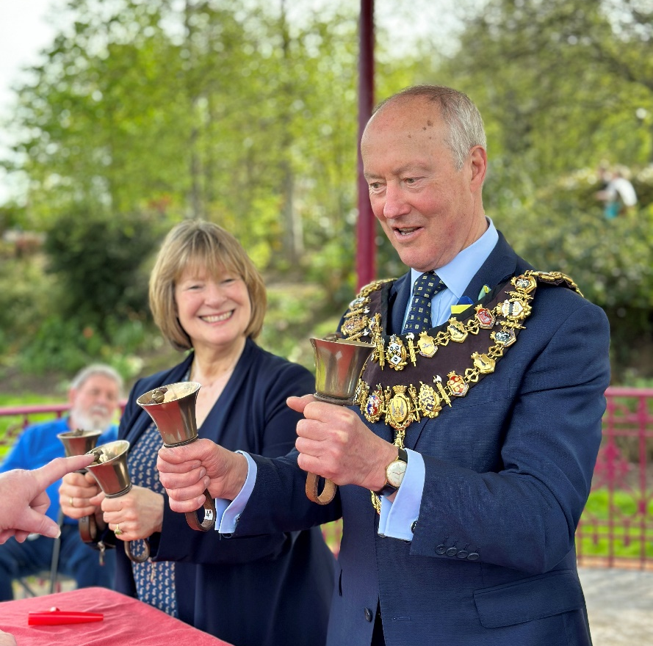
Newbury has an extremely rich cultural offering and as Mayor, I have been amazed at the extremely high quality of our local amateur musicians, actors and dancers. We do of course, host the Internationally acclaimed ‘Newbury Spring Festival’ where each year, the quality of the offering increases. The Spring Festival Committee are keen to look at ways to widen the musical offering provided and this includes working towards showcasing local young musicians and widening the genre of music performed.

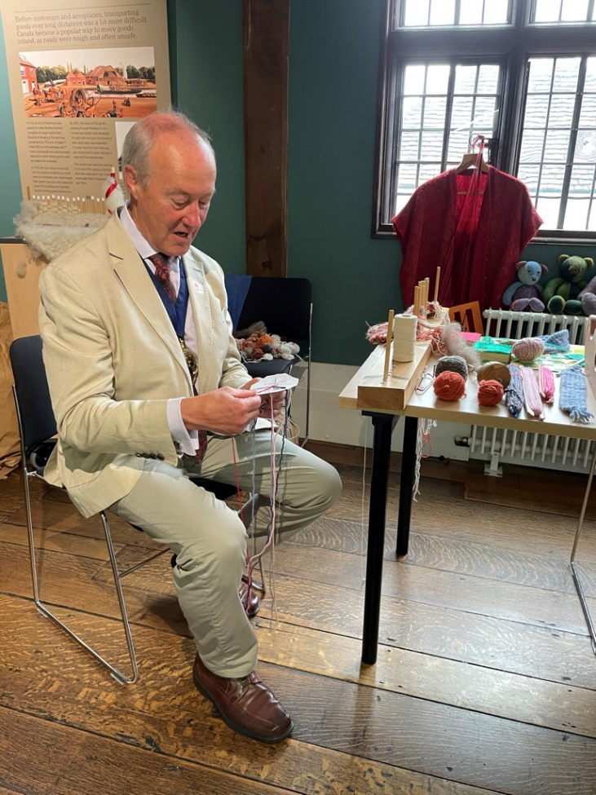
I have celebrated anniversaries of local jazz bands, young musicians through the West Berkshire Music Trust, the Newbury Symphony Orchestra, the Newbury Choral Society all of whom provide amateur music of an exceptionally high quality and this Town should be immensely proud of them. We have seen dance and song for young people through groups such as ‘Vox Fresh’ and seen exceptional drama productions from our local schools, as well as grown up drama groups such as the ‘Encore Players’ with their unconventional take on Shakespeare. My Lady Mayoress and I have also been treated to an exceptional play put on by asylum seekers, working under huge challenges, courtesy of the amazing people at The Refugee Support Group.

I have been privileged to attend many sport related events. A high point being the re-opening of the Faraday Road football ground and my colleague Cllr Andy Moore, was able to re-open football in Victoria Park. Newbury Town Council have been proud to install brand new outdoor fitness equipment at Victoria Park, for the use of everyone including wheelchair users and I was able to try most of the equipment out when opening it. Community United’s Community Cricket Day was a success despite the weather, and we had a women’s team taking part for the first time.

The environment is a key priority of the Town Council and so I was delighted to be able to help with tree planting and sunflower planting over my year as Mayor. In many cases, this work would not be possible without the help of willing volunteers, and it is a joy, as Mayor, to be able to thank those individuals.
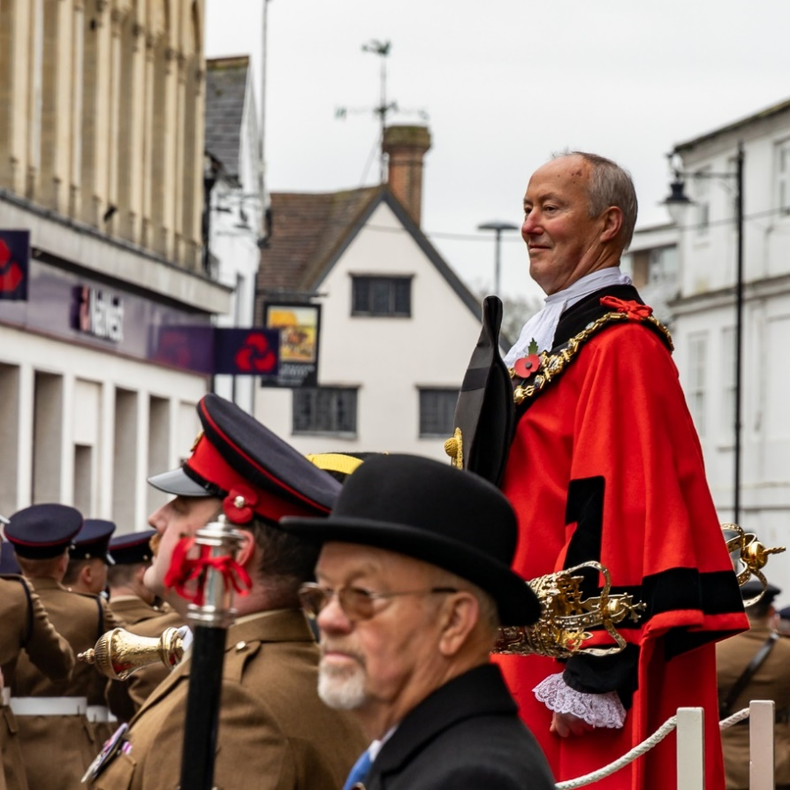
There are many solemn events in the Mayoral calendar. On these occasions, the Mayor represents the citizens of the town in acts of commemoration or remembrance. I have already mentioned Holocaust Memorial Day and of course, Remembrance Sunday is probably the biggest event in the Mayoral year. This year, we were very grateful to my Mayor’s Chaplain, the Reverend Will Hunter-Smart who conducted the service for 2023. I attended other Memorial Services at RAF Welford and at Greenham Common Control Tower. In addition, I should not overlook the sad event held at Shaw House, in February, to remember the second anniversary of Russia’s invasion of Ukraine. This event was attended by many Ukrainian families who have sought refuge in Newbury.

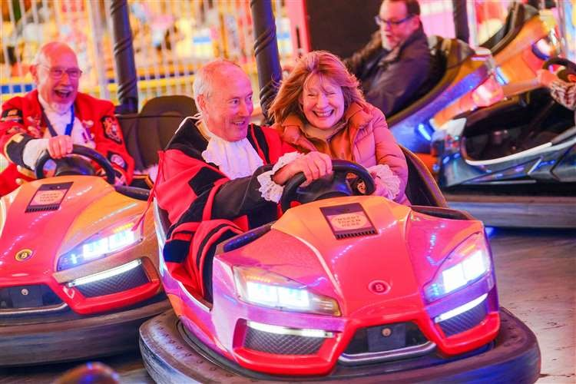
The Mayor has the pleasure of being guest of honour at many hugely enjoyable events. There is the Michaelmas Fair held at Northcroft Park each year at which the Mayor can fulfil every child’s dream of going on all of the rides for free! The Santa Fun Run, organised by the Rotary Club of Newbury, the Christmas Tree Lights Switch On and many, many other events!

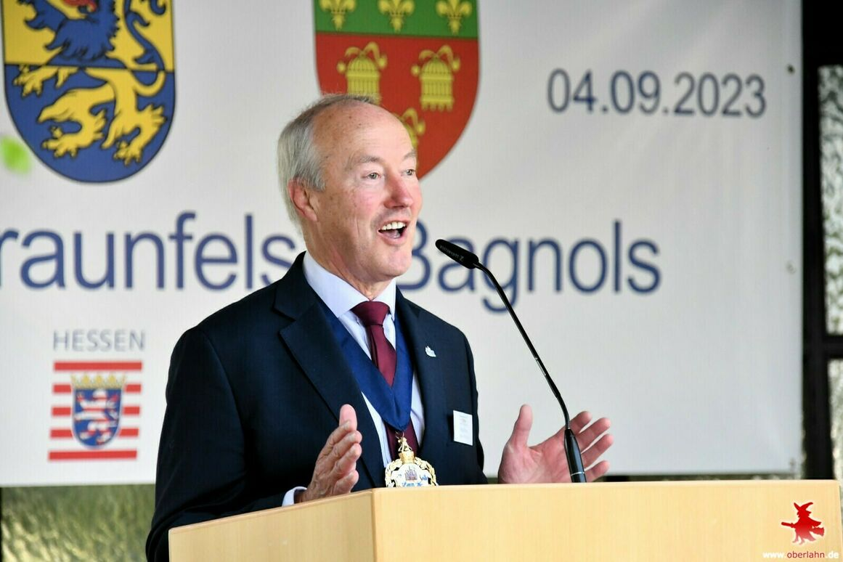
A particular pleasure for me in my year as Mayor, has been our Twin Town celebrations. One for our 60th Anniversary of twinning with Braunfels in Germany and a 50th Anniversary of our twinning with Bagnols-sur-Cèze in France. Keeping these links with our European neighbours and friends is something that is very close to my heart. Especially keeping a link open for our young people to connect with their peers in other European Countries, through the ‘Youth for Europe’ scheme.

So, as I reflect on my year as Mayor, I feel it has been a huge privilege. I have learned a great deal and a lasting impression for me has been the huge importance of bringing our community together, celebrating what we can achieve collaboratively and to never cease to be amazed at what ordinary individuals can achieve and how indebted we are as a Town, to them.
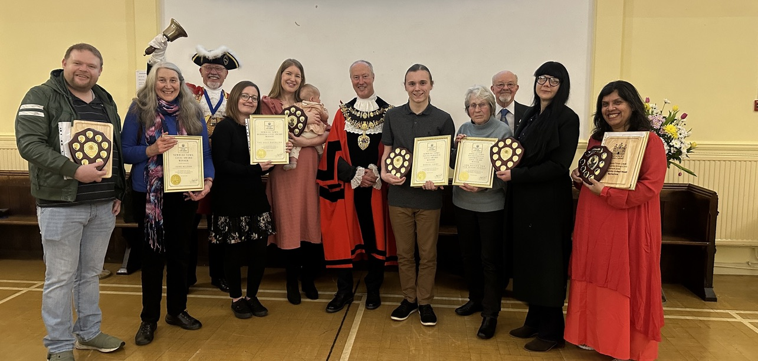

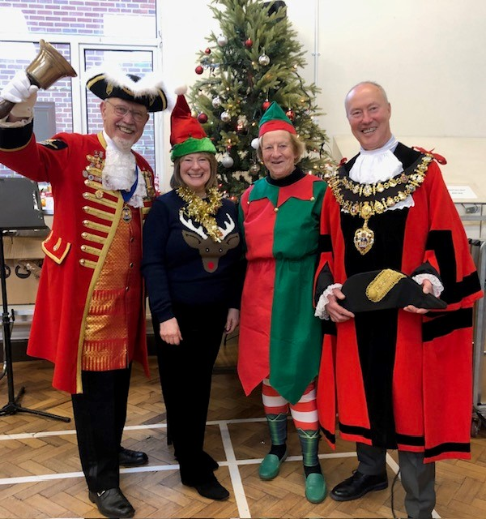
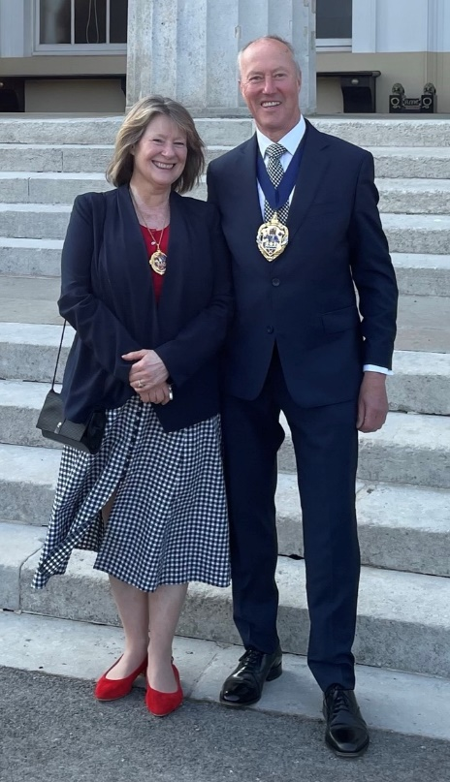
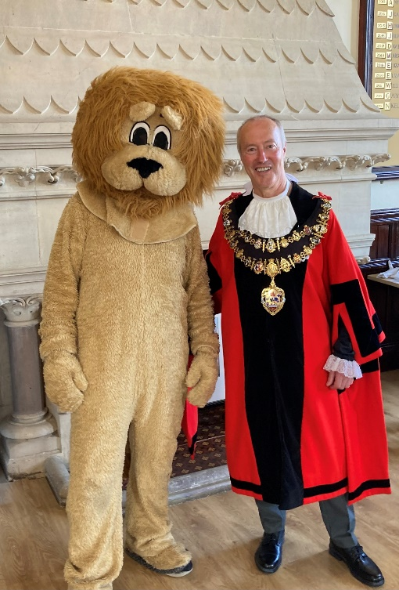
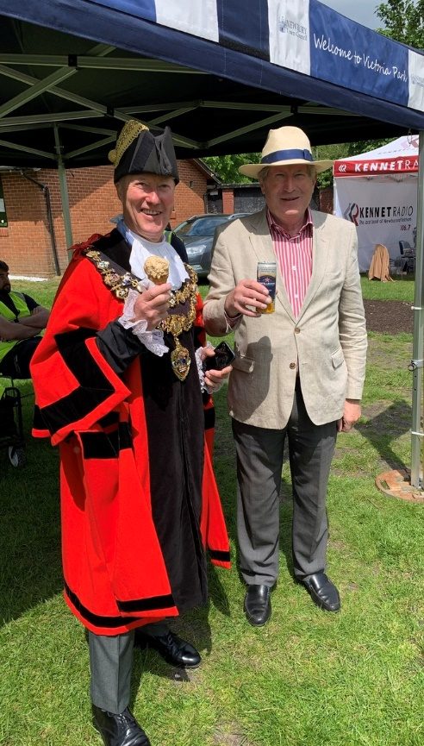
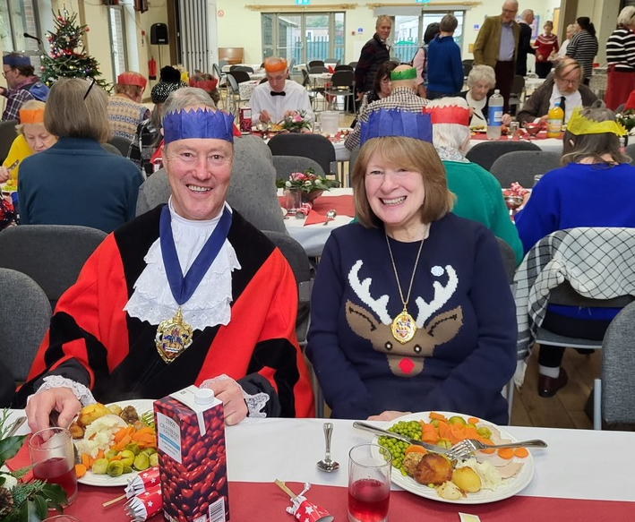
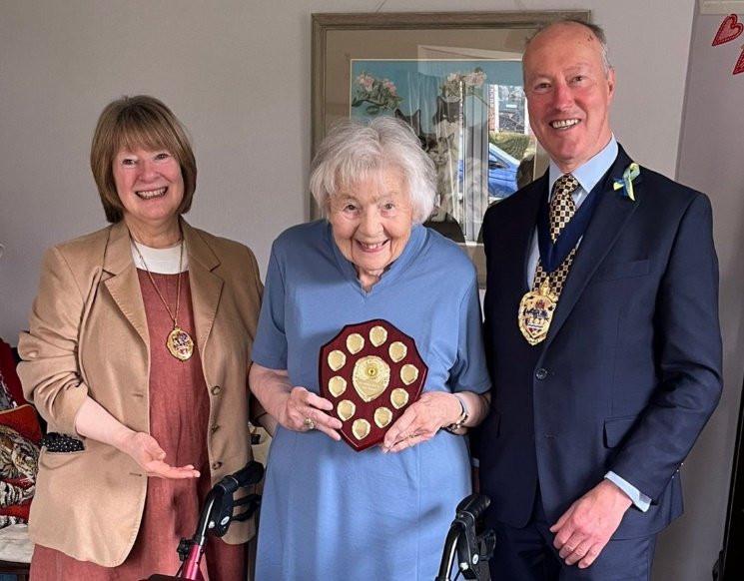
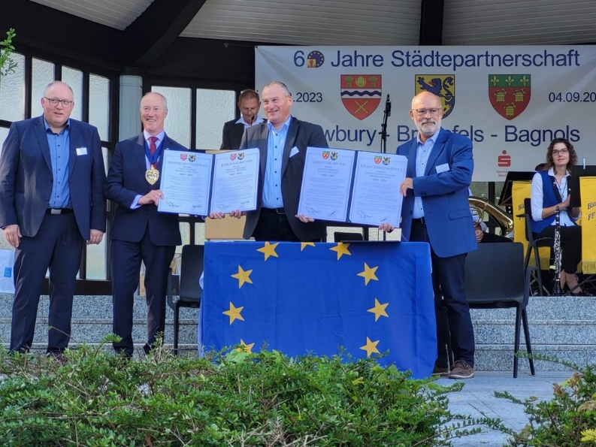

Newbury Town Council recorded its Thanks to
Councillor Nigel Foot
on behalf of the people of Newbury in recognition of his
Year in Office at Town Mayor
14th May 2023 to 12th May 2024

Present when the Seal of
Newbury Town Council
was affixed

Leader of the Council:
Gary Norman
CEO of Newbury Town Council:
Tobias Miles-Mallowan

Dated 12th May 2024
Town Mayor’s Report to Full Council
12th June 2023
Sunday 14th May - Mayor Making.
A very special day for me. We were blessed with fabulous weather!

This year’s Mayor Making was especially challenging because the local elections and the Coronation of King Charles III both occurred on the weekend before Mayor Making. In addition, our Civic Manager was on maternity leave over the period of Mayor Making. However, Elisa not only gave specific instructions for Amy and Virginia who were providing maternity cover for her but came in to help us with the actual ceremony. Amy and Virginia did amazingly well considering neither had any previous experience of Mayor Making! As always, Joyce Lewis came in to help with the robing up, Garry and Anthony were our Mace Bearers, Brian Sylvester, Newbury Town Crier, was master of ceremonies and Barry Digby was out Town Marshall. I had the pleasure of investing my wife, Sarah, as my Lady Mayoress and all our family came along to watch the Ceremony. I was very grateful to all the Civic Team who worked so hard to get everything together and make the day such a success.

Thursday 18th May - Eight Bells.
I attended the regular Eight Bells ‘Moveability’ Class, during Mental Health Week. This is an excellent, regular exercise class, run by Debbie. It is a ‘hybrid’ class with a ‘Zoom’ link to clients who are at home, and it is possible to carry out Debbie’s exercises from a chair for those with mobility issues. The message was, “no matter what challenges you have, some structured exercise is better than no exercise!” I was treated to a very nice meal afterwards.

Friday 19th May - Newbury Almshouse Trust.
I attended a very informative tour of the Upper and Lower Raymond Almshouses arranged by the Newbury Almshouse Trust.

Saturday 21st May - Victoria Park Family Day.
The annual Family Day was held in Victoria Park which looked especially well presented for the occasion. The weather was sunny and pretty warm. This encouraged a really good attendance. It was great to see the Bandstand in use again and we were entertained by the Ragtime Theatre School, ‘Whoosya’ folk band and Watership Brass. The Canal and River Trust were present to give out free food for the ducks and also provide information and advice about all things relating to the rivers and the canal. ‘Rugby Tots’ had some entertaining and energetic games for all the family, the Bowls Club and tennis courts were open and people could have a free try out of those facilities. The climbing wall was extremely popular with a lengthy queue all day. Berkshire Lowland Rescue were present to tell people what they did and to show some of their sophisticated equipment.
Thames Valley Police were also there, and the police van proved a very popular attraction. Berkshire Fire and Rescue had a fire engine in attendance, and this had a permanent queue of young visitors keen to look inside. The Mayor made rather a spectacle of himself dancing to some reggae played by the ever-present and entertaining Kennet Radio!

Monday 22nd May - SERFCA Briefing Royal Military Academy, Sandhurst.
I attended the South East Reserve Forces and Cadets Association Briefing with the Lady Mayoress. We heard about the important role reservists play in bolstering the UK Armed Forces. The need for local authorities to look after veterans living in their area, the Armed Forces Covenant and Cadet services. After the presentation, we were treated to an excellent curry!

Saturday 27th May - Kennet Radio, ‘Saturday Chatterday’ interview.
I had an interview with Kennet Radio about what the Mayor does. The interview was with Ray Wilton, which was great fun and I got to choose a track to play!

Sunday 28th May - Art on the Park.
An event supported by Newbury Town Council which was blessed with fine weather. A good number of people came along to view the exhibition and exhibitors were pleased with the amount of artwork sold.

Monday 29th May - Newbury Athletic Club, Newbury 10K running race.
Despite a chilly wind at first, the event was held in dry sunny conditions, almost perfect for running! A large field was made up of both juniors and children as well as adults and senior runners. 1000 runners took part in the event and Newbury Athletic Club did a great job with the organising. Lots of volunteers manned the course to keep runners on the right track and to keep hydrated. A lively soundtrack was provided by Kennet Radio and awards were provided by Stryker, Gardner Leader and Berkshire Youth.

Town Mayor’s Report to Full Council
23rd October 2023
Members, as always, the Mayor has been very busy with many local engagements since he was appointed on 14th May of this year.

Instead of reading out a long list of comments for each individual event I have attended, I would like to make some comments on how all of them have been such really enjoyable and worthwhile occasions.

It does not take a Mayor long to realise the huge contributions people make, both individually or as part of an organisation, to the social fabric of our Town. It is fair to say that without these contributions, Newbury would not be the vibrant and pleasant place it is, in which to live.

Consequently, it is a great privilege, as Mayor, to meet and thank so many of those who give up their time and effort for the greater good of our community. The Mayor has attended 77 engagements since 18th May, including a notable trip to Braunfels, in Germany, to celebrate the 60th Anniversary as Newbury’s first ‘Twin Town’.

The Newbury Blue Plaques continue to help to put the town on the map. And our thanks go to the Heritage Working Group for all their great work in uncovering all manner of interesting people and things that Newbury has been associated with in the past.

We attracted national news coverage when the surviving daughter of PC Albert Alexander came over from California to view his Blue Plaque and visit his grave in Newtown Road Cemetery. Our thanks go to the Friends of Newtown Road Cemetery for their research and help in organising this.

In addition, we have the first Blue Plaque related to a fictional event, namely the referencing of Newbury in the Thomas Hardy novel, ‘Jude the Obscure’. Members of the Thomas Hardy Society joined us for another very well attended ‘unveiling.’

So now, we look forward to the solemn events of Remembrance Sunday and onwards to the Christmas light ‘Switch On’ and events leading up to Christmas. I shall report on those at our next Full Council Meeting.

Finally, I would like to thank my excellent Mayor’s Cadets, Able Cadet Patrick Whitehead and Able Cadet Alisdair Shankland, who have carried out their duties so diligently and in such an impeccable manner.

Town Mayor’s Report to Full Council
22nd January 2024
The final few months of 2023 were very busy ones for the Mayor. The switching on the Town’s Christmas Lights was on the 18th November followed by the Mayor having the honour of helping in the Grand Reopening of the Faraday Road Football Ground.

The Mayor and Mayoress were almost as excited as the Newbury Beavers when we joined them for their sleepover at the West Berkshire Museum. We left them after about an hour and by all accounts, the children had a great time and slept well, which is probably more than can be said for the excellent Beaver Leaders in charge!

The Mayor was part of the 56th Birthday celebrations at Fair Close Day Centre, we attended the Falkland Grange Care Home Christmas Party and were involved in packing up the bags of provisions for the ‘Over 80’s Parcel Fund’ at Sainsbury’s - with the help of the local Cub Scout Groups. We hosted a party from our Twin Town of Bagnols-sur-Cèze and celebrated with them, the 50th Anniversary of our twinning.

Moving into December, the Mayor attended the solemn ceremony commemorating the tragic loss of both American and British service personnel in accidents at Greenham Common Airfield during the Second World War. Sadly the weather for this event was dreadful and one felt very sorry for the honour guard parties of USAF personnel and the Royal British Legion, who got absolutely soaked during the ceremony.

The Mayor’s Festive Tea Party was a great success. We had a full house of participants, our oldest being 102 and several guests were very close to that age! Our guests were treated to a heartwarming display of ballroom dancing and carol singing by St Nicolas’s Primary School, for which we were very grateful. A special mention has to go to the entire Civic Team for helping to organise and put on the event and make it such a success. I would also like to thank Councillor Vera Barnett who with some industrious baking and sandwich making together with her contacts at the Empire Cafe in Newbury, provided lovely food, beautiful Christmas decorations, all at a great saving in costs from last year’s event.

Of course at Christmas time, there are many Carol Concerts to attend, I couldn’t manage to go to all of them but my Deputy Mayor, Councillor Andy Moore, stepped into the breach when I was double booked and so my thanks go to him for all his help.

Christmas Day was busy with the Mayor calling into the Police Station, Fire Station and Ambulance Station to wish our emergency workers a Happy Christmas and to thank them for their service over the holiday period. We called into the Market Place to say Merry Christmas to the Soup Kitchen volunteers and to some clients who came along. Rufus Coffee House was open for those who had nowhere to go on Christmas Day and everything was free for those who could not afford to pay. Finally, the Mayor and Mayoress went up to the Christians Together In Newbury Christmas Party at St Georges Church Wash Common, for the lonely, elderly or residents living on their own who had nowhere else to go on Christmas Day. It was a very uplifting and humbling event.
At the same time, Councillor Andy Moore as Deputy Mayor was attending the West Berkshire Community Hospital for their Christmas Day Carols and visited patients and staff who were in the hospital over the Christmas period.

So now we are into 2024, the engagements are ramping up again after the Christmas break and I’m looking forward to the Spring and more events to attend!

Finally, I would like to pay a special thanks to Ms Virginia Robins for her help maternity cover for the Civic Manager who left us a week or so ago. Of course we also said goodbye to our Chief Executive Officer, Hugh Peacocke, who has moved out of Newbury. I am sure I speak for all previous Mayors who have been in office over the time Hugh was with the Town Council, that he was a great source of support and advice and we are all extremely grateful for his service to the Town.

Town Mayor’s Report to Full Council
18th March 2024
January 2024 was a fairly quiet month for the Mayor as it takes a little while for the engagements to start to flow following the Christmas and New Year.

On 20th January, it was my pleasure to attend the Royal British Legion County Conference that was hosted by the Newbury Branch of the RBL on Pelican Lane, and later in the month the Lady Mayoress and I were guests of Queen Anne’s School, Caversham for their Biennial Founders Celebration. This was held in the grand surroundings of Westminster Abbey and we were able to have a long chat with the newly appointed Lord Lieutenant of Berkshire, where we lost no time in extolling the virtues of our Town!

At the beginning of February, we were guests at the Art, Design and Technology Exhibition at Trinity School which was great fun and very well attended by enthusiastic students and parents. It is a reminder of what talented young people we have in our Newbury schools.

On 10th February, the Annual General Meeting of the Newbury Twin Town Association was hosted here at the Town Hall, and it was encouraging to see so many attendees. We had guests from Bagnols-sur-Cèze and I had to dust off my schoolboy French to welcome them. We look forward to our trip over to Bagnols in May, to celebrate the 50th Anniversary of our twinning with their town.

The Lady Mayoress and I attended the 17th Birthday celebration event of the Newbury Crafters at the Speen Parish Hall on 17th February. We spent a very interesting afternoon at that event, in fact the Lady Mayoress has now got into ‘quilling’ and is producing some truly extraordinary birthday cards!

21st February was a sober day as we joined with West Berkshire Council in Commemorating the Russian invasion of Ukraine. We listened and spoke to many of our Newbury Ukrainian guests. They continue to struggle with the daily worry of partners and relatives back in Ukraine, serving in the military or simply living under the constant threat of missile attacks. We listened and tried to imagine the emotions they have to deal with as they adapt to their new life in West Berkshire, yet at the same time longing to return to their homeland to live in freedom and peace.

On the 24th February, we were up at the Bowlers Arms in Wash Common to help celebrate a 100th Birthday which was great fun and a very happy event.

The following day, we helped hand over a cheque for £2000 to ‘Loose Ends’ at Newbury Cricket Club, from Newbury SEWA. They are a local Hindu charity that does an extraordinary amount of charitable work in the Town and so it was lovely to be able to thank them, once again, for all they do for Newbury.

In the afternoon we were at Newbury Methodist Church for the opening of the Newbury Repair Café. To give the Group their full title, they are the ‘Newbury and Thatcham Repair Café’ and so they will be alternating between Newbury and Thatcham, on weekends throughout the year. On that first day of opening, the Repair Café had a staggering 70 plus ‘customers’ and although not every item could be repaired that day, for many that couldn’t be fixed their owners were asked to come back again so the repairers could have more time on the job! The ability to have a cup of tea and a chat while your item is being repaired, is very much appreciated by some residents who can be isolated and lonely.

On 29th February, we hosted a Retirement Party for our faithful Mayor’s Attendant, Mr Ian Campbell. Ian has been a very valuable member of our Civic Team, not just in his unobtrusive guarding of Mayoral Chain, but in the helpful advice he could pass onto someone like me, who had not lived in Newbury long enough to know “who’s who”, when attending Civic functions in West Berkshire. We are truly grateful for his service.

This month, we held a very successful Mayor’s Coffee Morning were we managed to raise over £500 for my charity, West Berkshire Homeless. I am very grateful to the Civic Team for all their help in hosting and to many Councillors and members of West Berkshire Homeless who did so much baking and arranged the tables so beautifully.

On 3rd March, it was my privilege to attend the annual Memorial Service commemorating the crew of HMS Tigris, Newbury’s adopted submarine, which was lost with all hands in March 1943.

The Newbury Spring Festival has been launched and it was an honour and pleasure to be associated with this prestigious, international music and cultural event.

Newbury Town Council were pleased to have a table at the very well attended ‘Sustainability Living Fair’ held at the Corn Exchange Newbury on 9th March. It provided an opportunity for the Town Council to showcase what it has been championing and achieving in its drive to achieve carbon neutrality by 2030.

Finally, I was able to attend the Berkshire ‘Mock Trial’ Competition held at Reading Crown Court on Saturday with the Deputy Mayor, Councillor Andy Moore. We were impressed by all the young Year 9 students who had the daunting task of presenting a case for both the defence and the prosecution in the Crown Court.

I look forward to the last few months of my tenure and I have a feeling it will be as busy as previous 10 months have been!

Town Mayor’s Report to Full Council
8th May 2024
March was probably the busiest month I have had as Mayor. A major event that month was the Civic Awards Ceremony. This year we had so many attendees that we had to move, for the first time, from the Council Chamber to the Parish Hall of St Nicolas’s Church and we would like to thank them for facilitating that move.

The Civic Award Winners were;

The Newbury Town Civic Award winner for 2024 was Mrs June Milsom.
The Newbury Town Young Person’s Civic Award winner – Daniel Udry.
The Newbury Town Local Community Group Award winner – Community United West Berkshire.
The Newbury Town Business Civic Award winner – The Ugly Duckling
The Newbury Town Environmental Contribution Award winner – ARK (Action for the River Kennet)

The Mayor had the privilege of presenting the 2024 Civic Award to Mrs Milsom at her home, a few weeks after the Ceremony. June has provided incredible service to Girl Guide Association and to the Cubs and Scouts for over 50 years.

After the Annual Town Meeting on 18th March, the engagements came thick and fast. These included attending the impressive Trinity School, whole school play, ‘The Wizz’. The West Berkshire Music Trust Concert at the Hexagon, Reading, the 10th Anniversary Celebration of the West Berkshire Therapy Centre in Thatcham. Starting the Newbury leg of the Devizes to Westminster canoe race (this year reduced in length due to the swollen rivers) and the solemn remembrance service at RAF Welford, commemorating the loss a Lancaster bomber from 101 Squadron. Interspersed with those events, we had celebrations of important local individuals including a 100th Birthday party and the retirement event for Mr Garry Poulson, of the West Berkshire Volunteer Centre.

A high spot for me was the Mayor’s Concert, held at the Waterside Centre on 23rd March. I am particularly grateful to all the Civic Team who worked so hard not just in setting everything up, serving drinks and clearing away at the end but in organising the whole event including obtaining the services of some great local artists, Bruce Hogg, Project Band and The Rokkits. The whole evening was a great success and a good fund raiser for ‘West Berkshire Homeless’, the Mayor’s Charity.

A further Mayor’s fundraising event was held on 12th April when we hosted the ‘Mayor’s Quiz Night’ at the Town Hall. Once again, a good amount was raised for ‘West Berkshire Homeless’ and the strong competitive spirit of many Town Councillors was evident for all to see! Once again, a great deal of thanks are due to the Civic Team for all their help in promoting the Quiz Night, organising the raffle, providing the food and for clearing away afterwards.

I attended World Parkinson’s Day on the 13th April, where amongst other things, we had a lot of fun with ‘gazoos’. It is true to say that the ‘Blue Danube’ has never sounded quite like our rendition! The Mayoress and I attended a delightful event at Winchcombe Care Home in Speen, at the invitation of ‘Dementia Friendly West Berkshire’, where we saw how happy a care home specialising in dementia care can be, with such a professional and loving staff.

I was fortunate to be invited to Thatcham Town Council’s Civic Reception, by the Mayor of Thatcham, Councillor Mark Lillycrop on 19th April and the following day had three events to attend in Newbury. A Coffee Morning for Eight Bells for Mental Health, the launch of the West Berkshire Community Wellness Outreach Service in Northbrook Street and then the traditional ‘Mayor bowling the first wood’ event to start the Newbury Bowls Club season.

I was very pleased to attend a parade at Newbury Sea Cadets on the 1st May with the Deputy Mayor, Councillor Andy Moore. It has been a great pleasure to have not just one Mayor’s Cadet but two, over my year as Mayor. Able Cadets Patrick Whitehead and Alisdair Shankland have been immaculate when attending the Mayor on official duties and have been not just a credit to their uniform and Unit but to the Town as well. I would also like to thank the Commanding Officer of the Newbury Sea Cadets, Sub Lieutenant Anthony Battrum RNR, for all his help in co-ordinating the Mayor’s Cadets’ attendance at official events.

The Lady Mayoress and I had the great pleasure and honour of representing Newbury at the return visit of Newbury Twin Town Association, to Bagnols-sur-Cèze, last weekend. This was for the final part of the celebration of the 50th Anniversary of our Towns ‘twinning’. We were very well looked after and enjoyed the friendship and goodwill offered by all the Twin Town participants attending.

I would like to offer my sincere thanks to Mrs Elisa Mullen the Civic Manager at the Town Council. When Elisa came back from her maternity leave at the beginning of the year, I began to realise how key she was, not just to the Mayor, but for the entire civic role of the Council. Elisa was always good natured and very patient with me, gently reminding me that I was very late with presenting reports and generally nudging me when I needed reminding of things I had to do. I have been especially indebted to her for all her help with fund raising for the Mayor’s Charity.

So now I only have a few days left as Mayor and I can honestly say that this last year has been one of the best, most enjoyable and humbling years of my life. A lasting memory will be all the fantastic effort and contributions made by our citizens to the life of Newbury. A truly vibrant, welcoming and happy Town!

Thank you.

