**Newbury Town Hall Wedding & Civil Ceremony   
Booking Form**

|  |  |  |  |  |  |  |
| --- | --- | --- | --- | --- | --- | --- |
|  | Day |  | | CONTACT | Names of Couple |  |
|  |
| Date |  | | Contact Name |  |
| Address |  |
| Start Time |  | Hrs |
| Ceremony Start Time |  | Hrs | Email Address |  |
| Finish Time |  | Hrs | Contact Number |  |

You may arrive up to one hour before the ceremony to decorate the Council Chamber. Please request that your guests arrive no sooner than 30 minutes before the ceremony. The hire includes the use of the Council Chamber, Town Hall ceremonial entrance, hall, main staircase and landing. Please ensure that all members of your party vacate the Town Hall, and all your equipment and decorations are removed within an hour and a half of the start of the wedding ceremony.

|  |  |  |  |
| --- | --- | --- | --- |
| Prices | | | |
| Monday to Saturday | Sunday and Bank Holidays | Extras | |
| £462 | £594 | Chair Cover & Sash Hire  £85.00 |  |
| Laptop and Projector £25.00 |  |
| £100 Deposit Paid | Please pay directly into the Town Council’s bank account:  Acc no: 3476 1954 Sort code 40-51-62 | Hire of Glasses for Toast  £10.00 |  |

I confirm I have spoken to the West Berkshire Council Registrar and booked the registrar to perform the   
Wedding / Civil partnership.

I agree to hire the premises under the conditions set out overleaf to pay the appropriate charges for the hire.

I agree to ensure a nominated person is responsible for the delivery of the emergency evacuation procedure to our group.

Name (printed): .............................................................. Signature: ..............................................................  
Date: .............................................

Please enter details, retain a copy and return the signed copy/e-copy to Newbury Town Council, Town Hall, Market Place, Newbury, Berkshire, RG14 5AA to confirm your booking. For further details please contact 07951268883 or [Kym.heasman@newbury.gov.uk](mailto:Kym.heasman@newbury.gov.uk)



**CONDITIONS OF USE**

**When hiring the Council Chamber, the following conditions apply and should be read in conjunction with the ‘Conditions of Hire’:**

# Health & Safety

1. Regular hirers, please ensure that a copy of your current Public Liability insurance has been given to the Town Council.
2. The current Fire and Safety regulations require that a person attending your function is nominated to familiarise themselves with emergency procedures as included in this pack.
3. Should you hear the fire alarm, please do not use the lift. If you have a disabled member in your party, please report to reception prior to your meeting to ensure that appropriate emergency evacuation procedures are in place.
4. The Town Council operates a ‘No Smoking Policy’; users are asked not to congregate and smoke in the entrances to the Town Hall.
5. Do not block any exits.
6. Do not remove or tamper with any Fire Appliances.
7. Do not adjust or interfere with any heating controls.

# Upon Arrival and Set Up

1. Please be aware that Newbury Town Council’s offices do not open until **9.00am**
2. All setting up and clearing away of your equipment should be done within your booked times.
3. A charge will be levied if the Chamber, Suite or Servery is left in an untidy or unreasonable state.
4. The room will be set up to your specification and the tables locked together for safety purposes. If you wish to make an adjustment to the furniture please contact reception.
   1. Please do not unlock the tables yourself.
   2. If you are using tables for the setting out of food or drink, please ensure that your caterer uses heat resistant tablecloths.**\***
   3. If you are using tables to support equipment please ensure that the surface is protected.*

**\* *A charge will be made to the hirer if any furniture/fittings/fixtures are scratched or damaged in any way.***

1. No nails, tacks, pins, spikes, screws, sticky tape, blue tack or other similar items shall be used in any part of the premises hired (free standing boards are available on request).
2. When opening windows, make sure the windows are hooked into position.

**Never leave them to swing freely.**

Thank you.

**Newbury Town Council**

## Conditions of Hire

1. In these Conditions the following words have the meaning hereunder set out:-
   1. “The Council” is Newbury Town Council.
   2. “The Hirer” is the person named in the “Town Hall Function Room Booking Form” and is deemed also to include those persons defined in Condition 2 hereof.
   3. “The Proper Officer” is the person for the time being employed in that capacity by the Council.
2. All applications for the hire of the premises are to be in writing on the Council’s standard form of “Town Hall Function Room Booking Form”. The person by whom this booking form is signed shall be considered the Hirer. Where an organisation, club, company or other corporate body is associated with the application and named in the Town Hall Function Room Booking Form, they shall also be considered the Hirer and shall be jointly and severally liable with the person who signs the form.
3. A provisional booking must be confirmed by a completed “Town Hall Function Room Booking Form” no later than ten days after the date of the provisional booking, otherwise such provisional booking shall be cancelled. Cancellations should be made no less than 3 working days before the date of your booking. Charges will be levied for late cancellations.
4. The Hirer shall defray the expenses of making good any damage caused by the Hirer, his servants or agents, done to the building, fittings, fixtures, furniture or other property of the Council during or in connection with or in consequence of the occupation by the Hirer or his servants or agents of the premises and the Proper Officer for the time being of the Council shall be the sole judge of the damage done and the amount to be paid by the Hirer. Anything belonging to the Council lost or missing from any part of the premises during or in connection with any letting shall be paid for by the Hirer. The Proper Officer or his nominee shall be the sole judge of whether anything is lost or missing or of the amount to be paid by the Hirer. The Hirer shall also pay to the Council any loss the Council may suffer consequent upon such damage herein before specified.
5. The Council shall not be responsible or liable for or in respect of any damage to or loss of any property placed or left upon the premises. (Provided this clause shall not exclude liability of the Council for damage to any property caused by negligence of the Council’s employees).
6. Authorised officials and servants of the Council and Police and Fire Officers on duty, whether in uniform or not, shall be permitted to have free access to the premises at all times during the continuance of the letting.

## No exits may be blocked, chairs or obstructions placed in corridors or fire appliances removed or tampered with. Heating controls should not be interfered with.

1. The Hirer must arrange for the proper control of parking so as to ensure no obstruction to the access of the premises. The Council’s attendant on duty has the full authority of the Council to ensure that the Hirer carries out all other appropriate conditions correctly.
2. The Proper Officer or his nominee on duty has authority to refuse admission to any person or persons whom he thinks is undesirable to admit and the Hirer shall take steps to implement such refusal.
3. The hire of the premises does not entitle the Hirer to use or enter the premises at any time other than the specific hours for which the premises are hired unless prior arrangements have been made with the Proper Officer.
4. The Hirer shall:-
   1. not perform, play or use or permit to be performed, played or used any work or recording in which copyright exists except with the consent of the owner of such copyright;
   2. indemnify the Council against all claims, demands, actions and proceedings arising out of any infringement of copyright occurring during the period of hire;
   3. comply with the conditions of the licence held from the Performing Rights Society Limited, and shall furnish direct to the Proper Officer within seven days of the date of the function, a completed programme return of all music performed by the Hirer or by anyone engaged to play music on the Hirer’s behalf;
   4. If the form is not received by the Proper Officer within the time stated, the Hirer will be liable to a penalty of £10.00;
   5. if musical works are performed at any function the Hirer will be required to pay a further fee of 5% of the total hire charge, unless written evidence of payment of copyright fee for all works can be produced.
5. The Hirer, shall, if called upon by the Proper Officer, or his nominee, provide full particulars and furnish for approval at least two days prior to publication or distribution, a copy of the programme of any event and copies of all advertising material relating to the event and the Council reserves to itself the right to cancel any engagement in the event of the particulars advertising and/or programme not being approved.
6. The Proper Officer or his nominee shall have the power to object or strike out any words which she considers objectionable in all bills, notices, announcements, programmes, tickets or any matter to be used for a function at any time, unless these have been approved by her.
7. Material advertising functions to be held at the Council Offices must be displayed only in proper places throughout the District and the neighbouring areas. Fly-posting is not permitted. The Council reserves the right to cancel a booking without payment of compensation if a Hirer or any party engaged by such Hirer is responsible for fly-posting with window bills or posters advertising the event. Use of display on the front of the Council Offices can only be made with the consent of the Proper Officer.
8. Hirers are reminded that it is an offence under the Town and Country Planning Acts to display advertisements without the consent of the Planning Authority.
9. No decoration shall be erected or suspended from any part of the premises except such as can be erected so as to ensure that no damage is done to any part of the premises as a consequence thereof.
10. Inflammable materials must not be used in equipping and decorating the premises unless they have been rendered fire resistant and maintained in that condition.
11. No nails, tacks, spikes or screws or other similar articles shall be driven into any of the walls, windows, doorways or staircase or in any floor or in any part of the premises hired. Blutac must not be used on any emulsion surfaces.
12. No additional lights or extensions of the existing electric light fittings shall be used nor shall any electrical wiring or other fitments of a similar nature be fixed or placed in the premises without the previous written consent of the Proper Officer.
13. The Hirer shall not do or permit to be done anything whereby the fire risk to the premises or its contents is extended beyond that covered by the Council’s policy or polices of insurance without previously acquainting the Council in writing of his intention and expressly referring to this condition. It shall be the Hirer’s duty to acquaint himself with the terms of such policy or policies and any additional premiums payable to the Insurers shall be discharged by the Hirer.
14. The Hirer shall not permit anything to take place on the premises during the hiring which is unlawful or of disreputable character or contrary to the public decency or good behaviour or in any way such as to endanger any licence held in connection therewith and the Proper Officer or his nominee shall have power to remove any offender.
15. The Hirer shall not assign, sub-let or transfer or attempt so to do any interest he may have in the hiring of the premises or any part thereof, without the consent in writing from the Proper Officer.
16. The Council reserves the right to stop any entertainment or meeting not properly conducted and the Council may, if it thinks fit, charge the Hirer for any extra expense it may incur in engaging Police Constables or other Officials of the Council to preserve order prior to, during or after any entertainment or meeting in the premises.
17. The Council reserves the right to:-
    1. cancel this agreement if the premises are destroyed or damaged by fire, flood, act of God or any accident whatsoever;
    2. cancel this agreement if any work is being or is to be carried out in, on, over or under the premises involving any repairs to the premises, whether structural or otherwise, or any painting, decoration or other alteration whatsoever of the premises;
    3. cancel any booking by giving not less than 14 days notice;
    4. vary the letting charges at any time upon giving to the Hirer notice in writing 28 days prior to the date of a confirmed booking and in such circumstances the Hirer shall be at liberty to cancel the booking within seven days of the date of such notice and the whole or any part of the letting charge shall be refunded;
    5. cancel this agreement if the premises are required for any purpose in connection with a European, Parliamentary, or Local Election;
    6. cancel this agreement at any time if the Council thinks fit to do so, in consequence of War, civil insurrection, strikes, lock-outs or disturbance with the populace, whether actual or anticipated whatever the object of the Council in so doing may be, but including in particular, the object of obtaining the premises or any part thereof for the purpose of the Council or purposes other than the hiring thereby agreed upon and with the object of preventing any damage, loss or injury which may be occasioned by the Council in consequence of the use of the premises by the Hirer.
18. In the event of any such cancellation referred to in Clause 24 hereof, any deposit or other money paid for or towards the charges for the hire of a proportionate part thereof if the hiring has commenced shall be returned by the Council to the Hirer and in any such event the Council shall not incur any other liability to the Hirer.
19. The maximum number of persons to be admitted to the premises is the figure indicated by the Proper Officer.
20. The Hirer shall at the expiration of the period of hiring leave the premises in a clean and orderly state to the satisfaction of the Proper Officer or his nominee. Failure to do so may result in further charges being incurred.
21. The Hirer shall leave the premises hired and the fixtures, fittings, furniture, articles and things therein in a clean and good order and condition.
22. The Hirer shall, unless having specific permission from the Proper Officer, remove all articles brought into the premises by him, immediately after the expiration of the period for which the premises were hired.
23. The use of the premises shall include only those parts of the premises indicated to the Hirer by the Proper Officer or his nominee.
24. The premises are for hire only at the discretion of the Proper Officer and he shall have the absolute right to decline any application without offering any reason thereof.

## Please note that there is a no smoking allowed policy in the Town Hall.

# PLEASE ENSURE THAT ALL STAFF AND VISITORS ARE AWARE OF THIS EVACUATION PROCEDURE.



**EMERGENCY EVACUATION PROCEDURES COUNCIL CHAMBER**

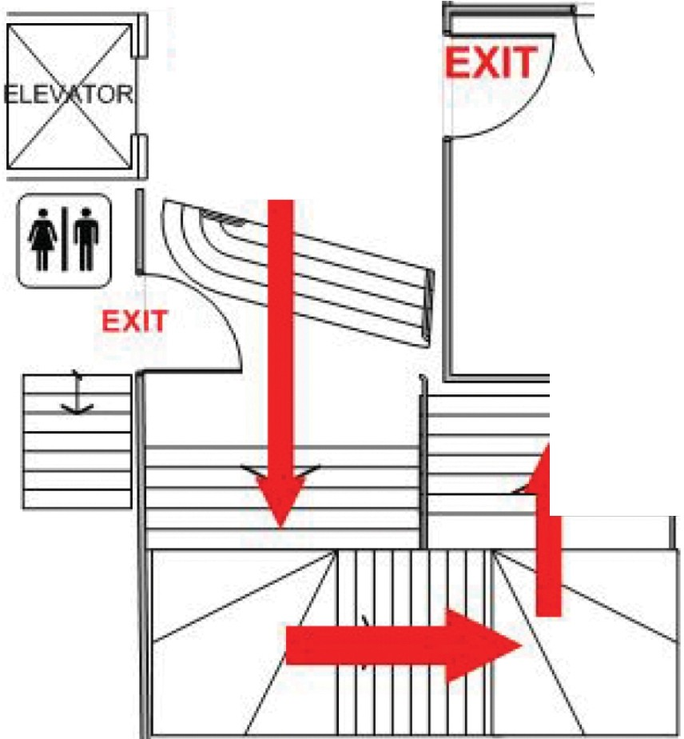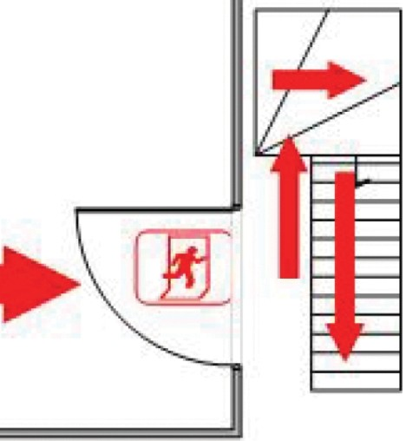

MAYORS

PARLOUR

EvacChair Location

CHAMBER

(1st Floor)

I!:==

EvacChair Location

SERVERY

CIVIC OFFICE

CARETAKER

07787 558471

**The FIRE ALARM is a continuous ring**

On hearing the alarm: -

1. Leave the building by the nearest exit.
2. Your nominated person/fire marshal must check all toilets and other areas to ensure that all persons in your group are clear of these areas.
3. Do not collect personal belongings.
4. Close internal doors.
5. Assemble in the Market Place outside the Cancer Research Charity Shop.
6. Take a roll call of all persons under your control.
7. Do not re-enter the building until advised to do so by a Fire Officer. In the event of a drill, permission will be given by a Fire Marshal or Officer of Newbury Town Council.

# FIRE ALARM TESTING

The Fire Alarm will be tested every **Monday** *(or the first working day after Bank Holidays)*

between 5.00pm and 5.15pm.