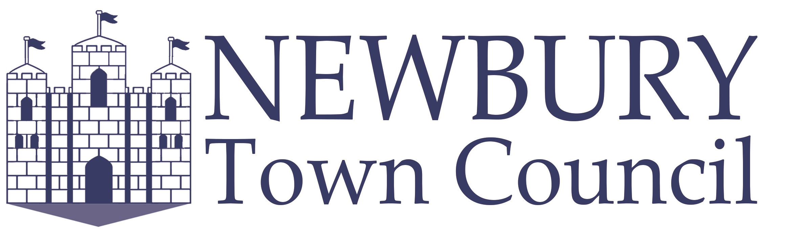

THE NEWBURY TOWN COUNCIL CIVIC AWARDS 2025 NOMINATION FORM

We continue to ask for nominations of people in Newbury who work extremely hard in a voluntary capacity for the benefit of our local community. This year we have five awards available: The Newbury Town Civic Award, The Newbury Town Young Persons Civic Award, Newbury Town Civic Award for Business, The Newbury Town Civic Award for Environmental Contribution; and The Newbury Town Local Community Group Civic Award.

AWARD CATEGORIES

Please ensure you read all the information to make sure your nomination is eligible to be submitted. Groups are welcome to be nominated for all awards.

The Newbury Town Civic Award
This award recognises a person, or couple, who have voluntarily given exceptional service to their community. This person does not have to live within Newbury Town; however, their voluntary activities should be predominantly within Newbury Town or benefit the town.

The Newbury Town Young Persons Civic Award
This person must be aged 25 or under. They don’t have to live in Newbury Town; however, their voluntary activities should be predominantly within Newbury Town or for the benefit of the town.

The Newbury Town Local Community Group Civic Award
This award is dedicated to the work of local groups who provide a service to the benefit of the community. The members of the group do not have to live within Newbury Town; however, their voluntary activities should be predominantly within Newbury Town or benefit the town. Group sizes consisting of 3 or more members will be considered for this award.

The Newbury Town Business Civic Award
The Town Council wants to acknowledge the contributions made by the many businesses who are giving something back to the community in Newbury. This could be through employees volunteering for local causes, through fundraising or contributions, or by partnering with local charities and organisations. The business does not have to be located within Newbury Town; however, the contribution or volunteering activities should be predominantly within the town or for the benefit of the town.

The Newbury Town Environmental Contribution Civic Award
The Town Council wants to acknowledge the contributions made by individuals and organisations whose volunteering impacts the local environment by helping to reduce CO2 emissions, or to reduce/recycle more waste, or to increase biodiversity. This could be through conservation projects, green initiatives, fundraising, or by awareness raising. The individuals or organisations do not have to be located within Newbury Town; however, their contribution or volunteering activities should be predominantly within Newbury Town or for the benefit of the town.

A presentation of the Awards will take place on Wednesday 19th March 2025, where all nominees will be invited to attend.

Please complete and return this form no later than
Friday 28th February 2025.

Please select which award you would like to nominate this person/organisation for (only one award per nominee):

- The Newbury Town Civic Award
- The Newbury Town Young Persons Civic Award
- The Newbury Town Local Community Group Civic Award
- The Newbury Town Business Civic Award
- The Newbury Town Environmental Contribution Civic Award

Nominees Name
Age (for Young Persons Award only)
Address
Tel No
Email Address
*At least one method of contacting the nominee must be supplied.

Reason for Nomination: (please provide, in no more than 500 words, we should consider this person/organisation for the Award, and why they deserve the accolade. This portion of the nomination is fundamental for the judging panel to consider the nominee.) These questions may support you in your submission; what is the voluntary role that is carried out? / How long have they been volunteering? / How often do they volunteer? / What or who benefits from what they do? What makes this person stand out from everybody else? / Any further information that may support your nomination.

Nominated By:
Name
Address
Tel No
Email
Organization (if any)
Signature
(e-signatures accepted)
Date

Please return to the email or postal address below no later than Friday 28th February 2025. Announcement of the Awards will take place on Wednesday 19th March 2025.


All data collected will be used for the purpose of The Newbury Town Civic Awards and unless requested and approved for publicity purposes will be destroyed within 30 days of the 19th March 2025.

