GM 008 – Grit Bin Survey Data - 2021
Newbury Town Council
GM Contract supporting data

 | Location of Grit Bin: | Owned By / Comments:
 | Dysons Close Junction of Russell Road  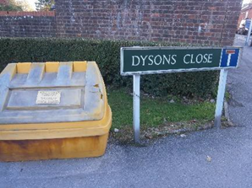 | WBC  ¾ full
- . | Lipscombe Close, Newbury  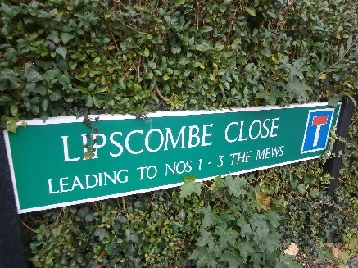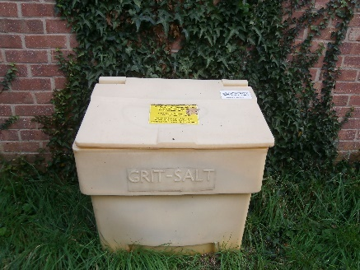 | NTC  Full
 | Chalford Road. In front of substation, near to Craven Road  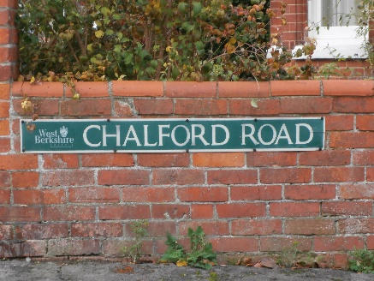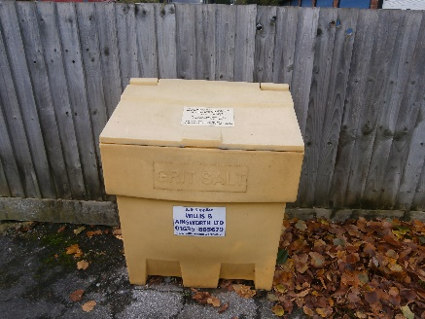 | WBC  ¾ full – Remove Dog Poo Bag & refill
 | Rockingham Road (approach from north to railway bridge, near junctions with St Michaels Rd and St Georges Ave.  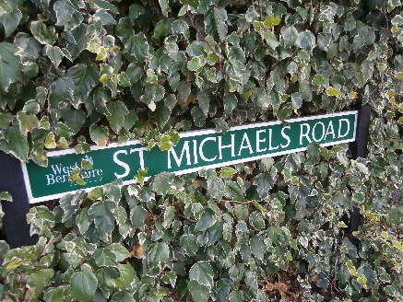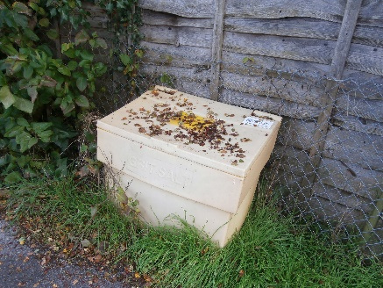 | NTC  ¾ full
 | Enborne Place on the corner of Enborne Grove  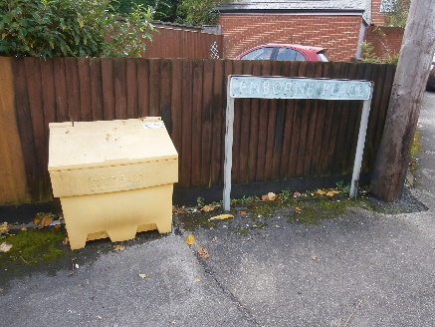 | NTC  ¾ full

 | Location of Grit Bin: | Owned By / Comments:
 | Bartlemy Road junction of Montgomery Road  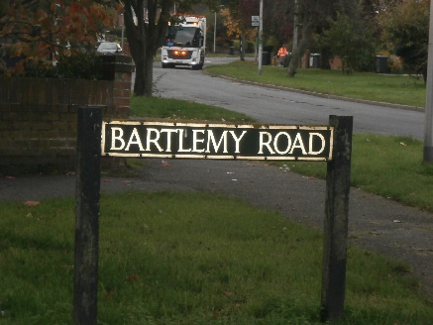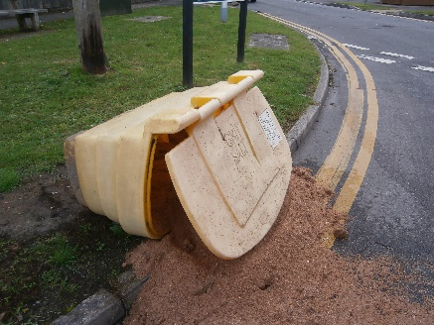 | WBC  Fallen Over Needs picking up and  refilling
 | Sidestrand Road by post box  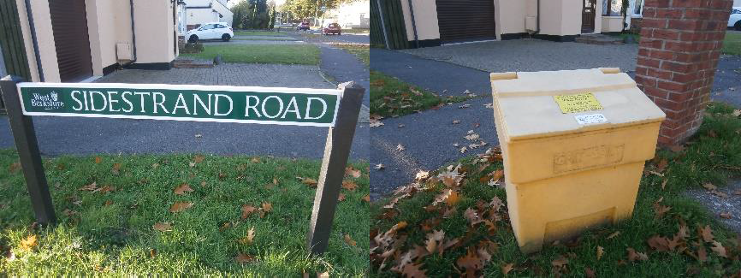 | NTC  ¼ full
 | Appletree Close  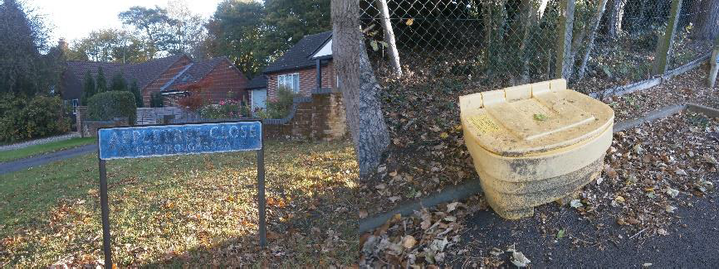 | WBC  Full
 | Sidestrand Road other end  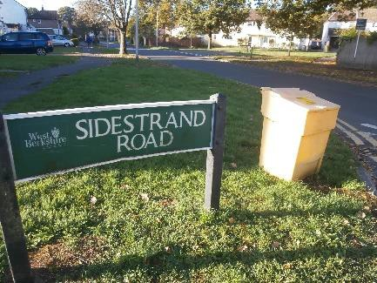 | NTC  ¼ full
 | Woodside RG14 6HL –halfway along the curved road  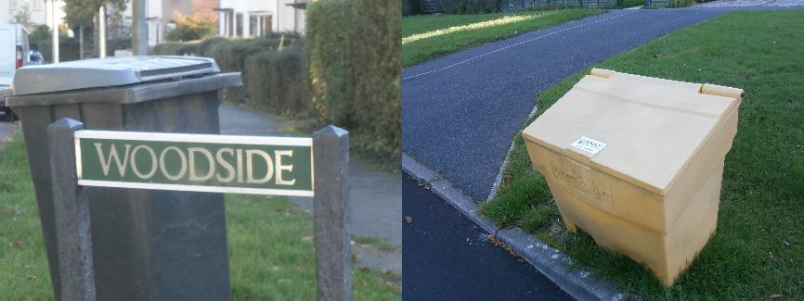 | NTC  ¾ full

 | Location of Grit Bin: | Owned By / Comments:
 | Pond close and junction of Elizabeth Ave.  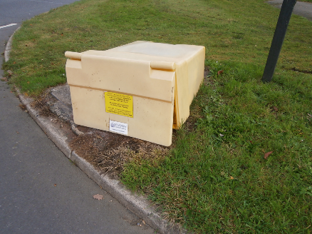 | NTC  Fallen over needs picking up & refilling
 | Pond Close – Turning point at the opposite end of Road  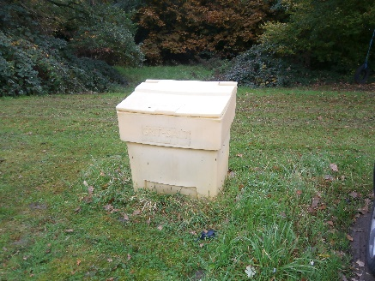 | NTC  ¾ full
 | Smallridge  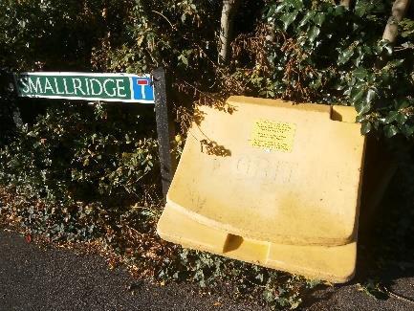 | WBC  ½ full
 | Badgers Ridge outside No. 2  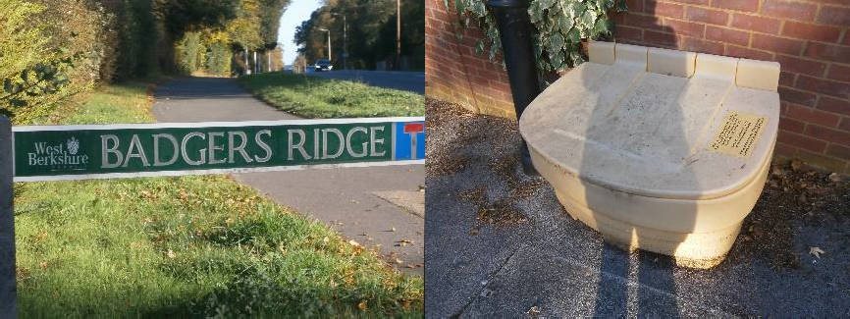 | WBC  ¾ full
 | Conifer Crest Junction of A343 Andover Road  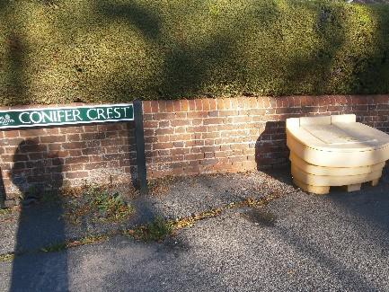 | WBC  Full

 | Location of Grit Bin: | Owned By / Comments:
 | Conifer Crest Junction of Normay Rise  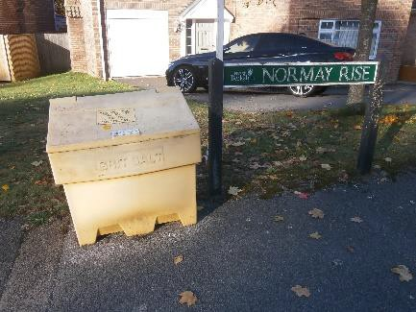 | NTC  Empty
 | Conifer Crest on verge by No. 19  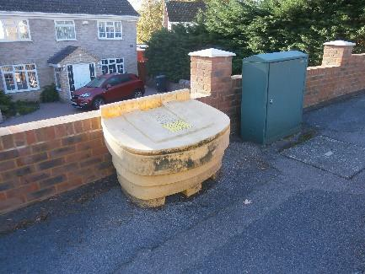 | WBC  Empty
 | Holborne Close junction of Glendale Avenue  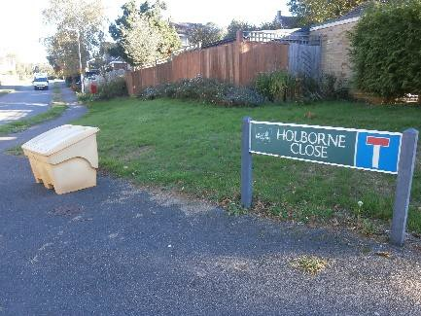 | WBC  Empty
 | Cheviot Close at the junction of Glendale Avenue  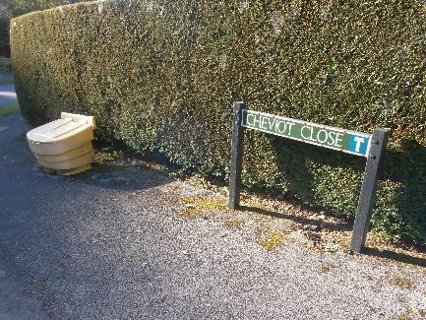 | NTC  Empty
 | Bunkers Hill underneath chestnut tree  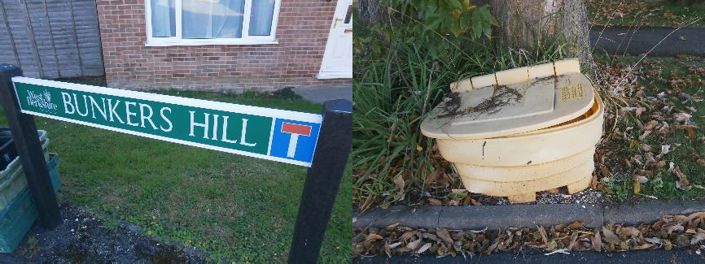 | WBC  Empty

 | Location of Grit Bin: | Owned By / Comments:
 | Wash Common Library / Community Centre, Glendale Avenue  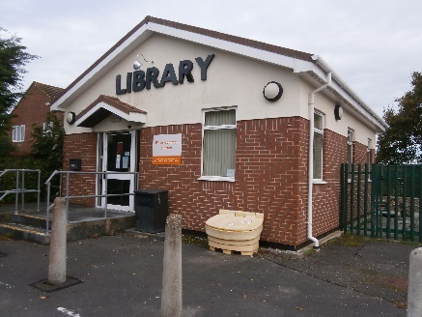 | NTC  Full
 | Battle Road by Wash Common Recreation Ground Car Park  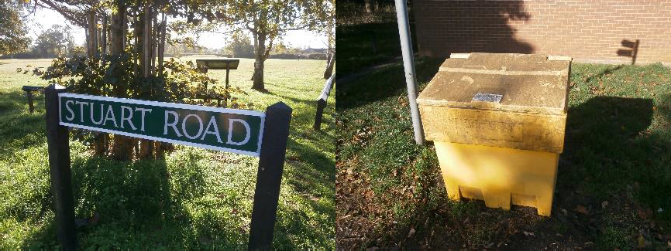 | NTC  ¾ full
 | Falkland Garth Junction of Essex Street  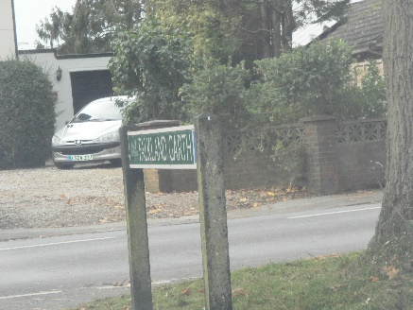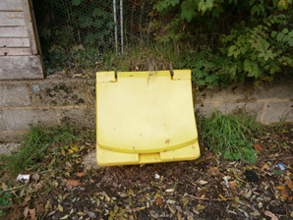 | WBC  Moved from location adjacent to sign – found by first set of Garages, relocate and fill
 | Falkland Garth off Essex Street, adj No. 56 by garage wall  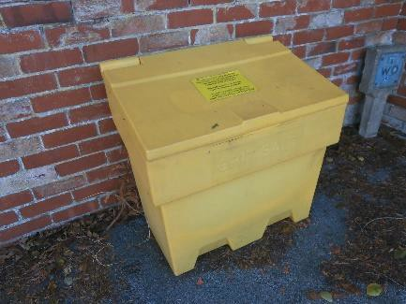 | NTC  Empty
 | Gorselands, Wash Common, adj. to flats 29, 31, 33, & 35  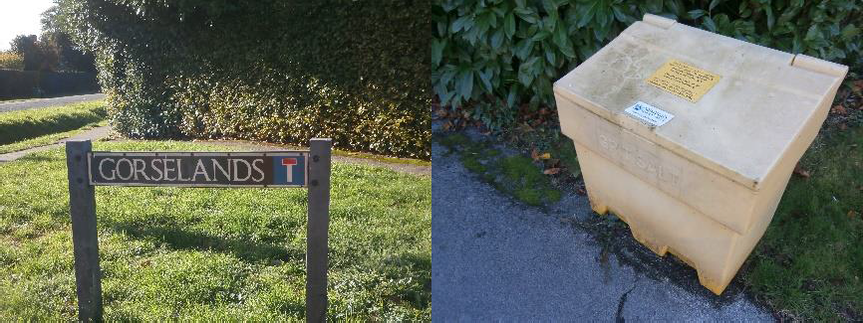 | NTC  Empty

 | Location of Grit Bin: | Owned By / Comments:
 | Sunley Close, off Warren Road, outside No: 5  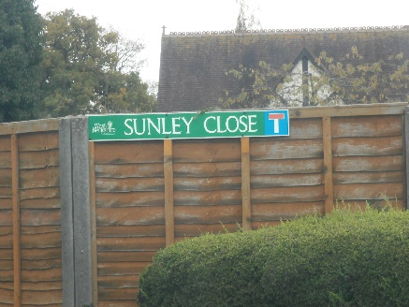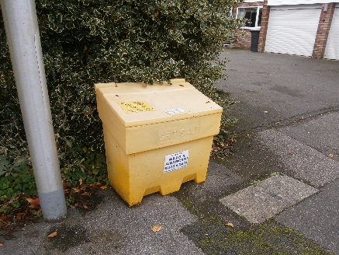 | NTC  Empty
 | Monkswood Close outside No. 26  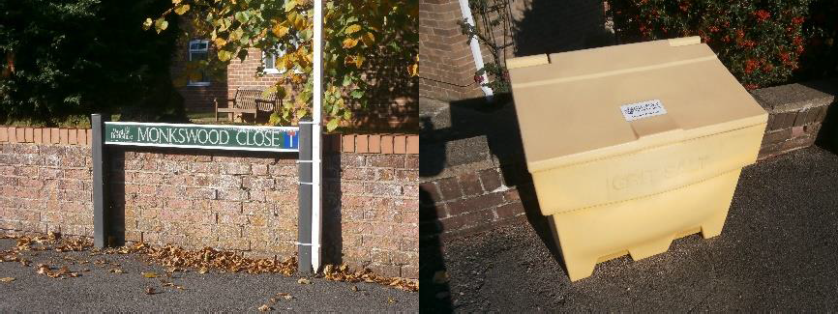 | NTC  ¼ full
 | Kingsland Grange, Newbury  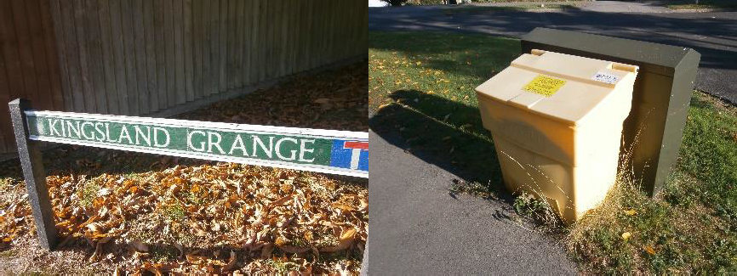 | NTC  Full
 | Falkland Drive, Newbury  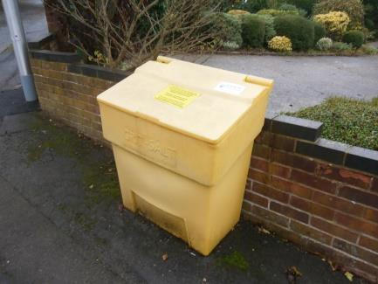 | NTC  ¼ full, the residents use cut down milk bottles to sprinkle the grit – Please don’t remove
 | Three Acre Road  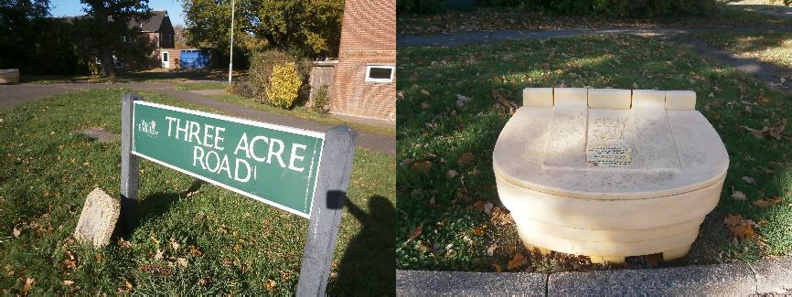 | WBC  Full

 | Location of Grit Bin: | Owned By / Comments:
 | The Glade / The Marlowes / Roebuts Close  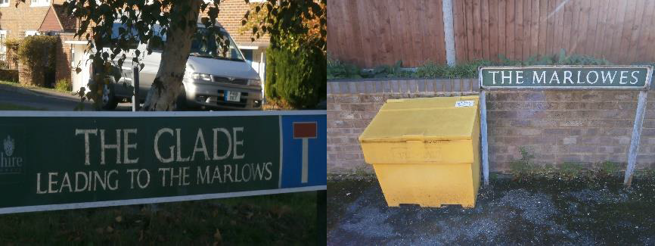 | NTC  ¼ full
 | Bruan Road (No. 7)  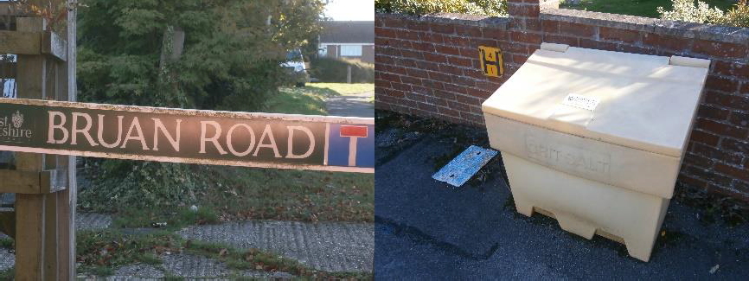 | NTC  ¾ full
 | Croft Road – Wendan Road End  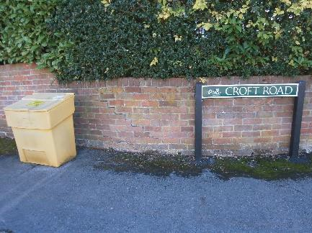 | NTC  Empty – Remove rubbish and refill
 | Croft Road - Halfway along  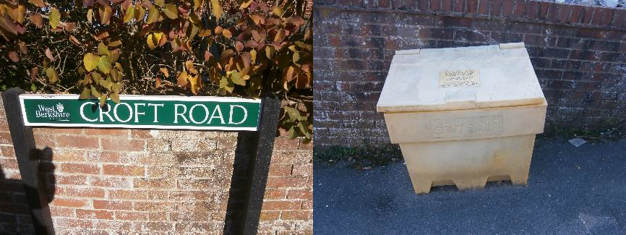 | NTC  ¼ full
 | Westmead Drive junction of Paddock Road  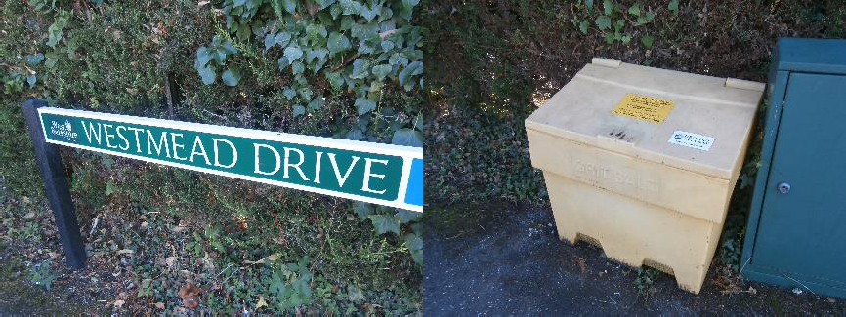 | NTC  Empty

 | Location of Grit Bin: | Owned By / Comments:
 | Meadow Road – junction of Paddock Road by substation  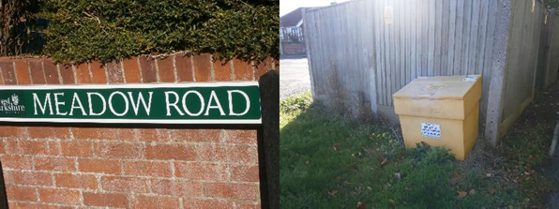 | WBC  ¼ full
 | Porchester Road on the Corner of Chesterfield Road  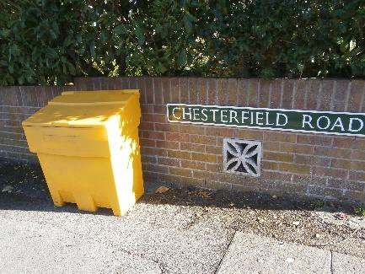 | NTC  Emptyl
 | Friars Road Junction of Newtown Road | WBC  Missing – Replace with NTC Stock held at Shaw and fill
 | Courtlands Road at the entrance onto Greenlands Road  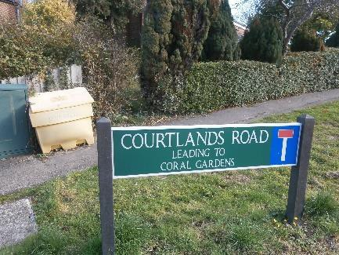 | NTC  ¼ full – difficult to left lid
 | Cheriton Close outside No: 15  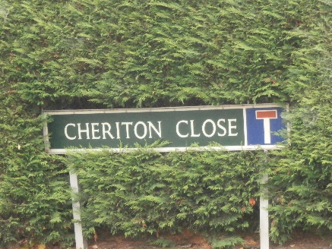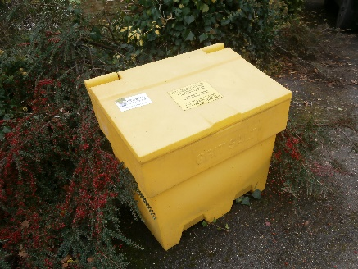 | NTC  ½ full

 | Location of Grit Bin: | Owned By / Comments:
 | Westlands Road  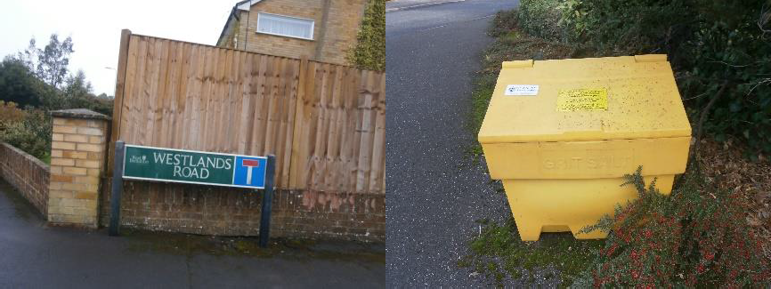 | NTC  Empty – Leave container for spreading
 | Ferrier Grove/Gaskell Mews/Howarth court direction  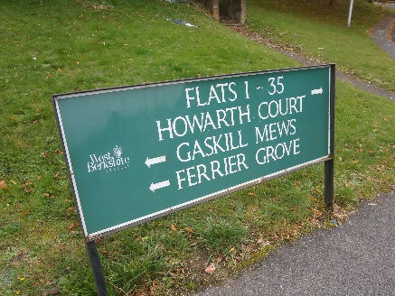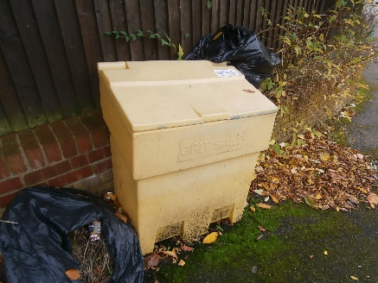 | NTC  Empty – remove rubbish and refill
 | Christie Heights at the Junction of The Nightingales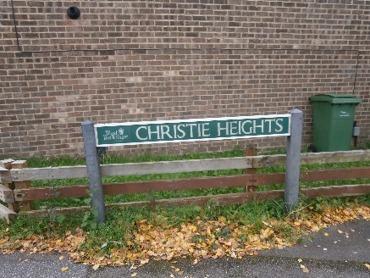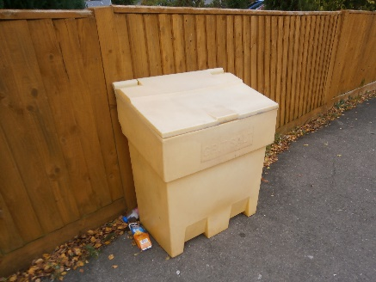 | NTC  Empty
 | Austen Gardens  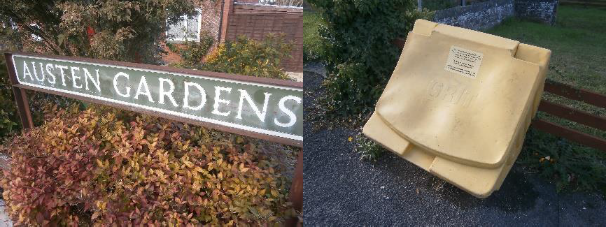 | WBC  Empty
 | Stanley Road / Livingstone Road  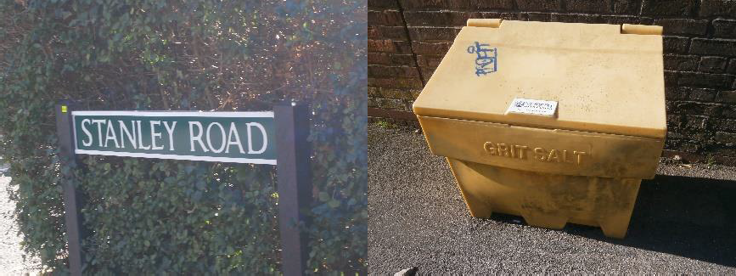 | NTC  ¾ full – remove rubbish and refill

 | Location of Grit Bin: | Owned By / Comments:
 | Newport Road (66)  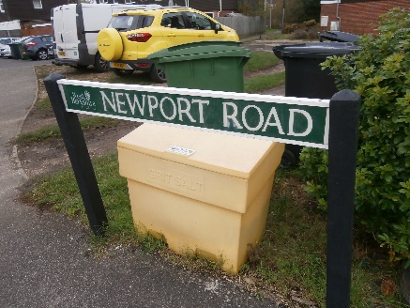 | NTC  ¼ full
 | Shaw Cemetery Top in Carpark  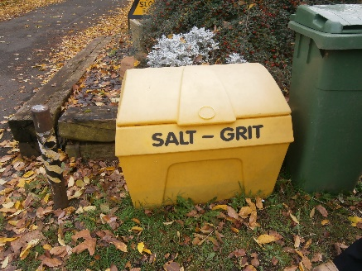 | NTC  ½ full
 | Shaw Cemetery Front of Chapel  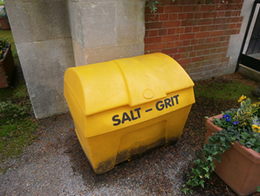 | NTC  ¼ full
 | Shaw Cemetery Rear of Chapel  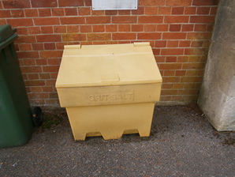 | NTC  Empty
 | Shaw Cemetery by Cromwell Road Gate  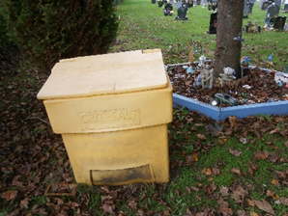 | NTC  ½ full

 | Location of Grit Bin: | Owned By / Comments:
 | Northwood Drive Junction of Kiln Road  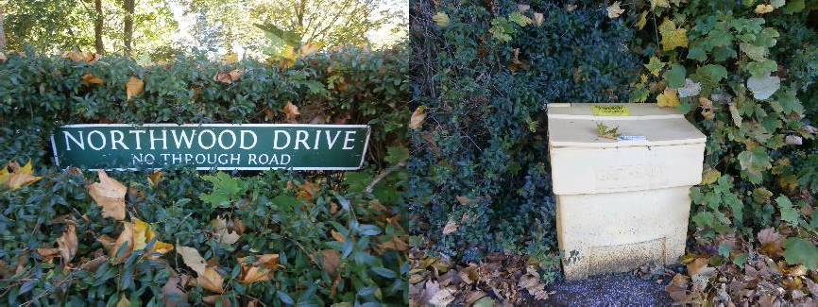 | NTC  ½ full  Remove rubbish & refill
 | Kiln Road, eastern side junction with Pear Tree Lane  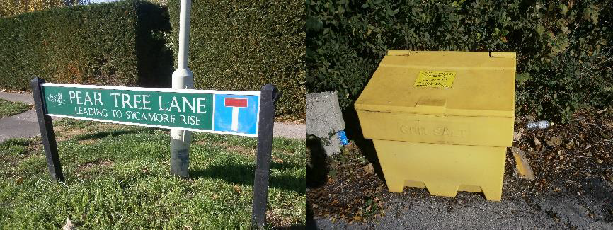 | NTC  Empty – rubbish (bathroom cabinet?) to be removed then filled with grit
 | Gaywood Drive Junction of Turnpike Road  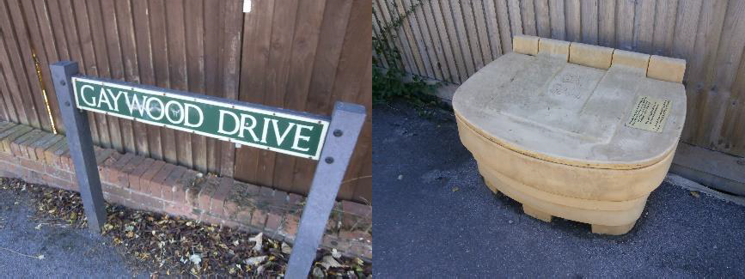 | WBC  ¼ full
 | Fieldridge Junction of Stoney Lane  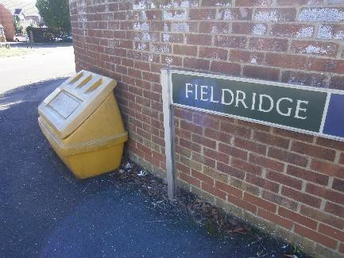 | WBC  Empty
 | Harrington Close adjacent No: 25  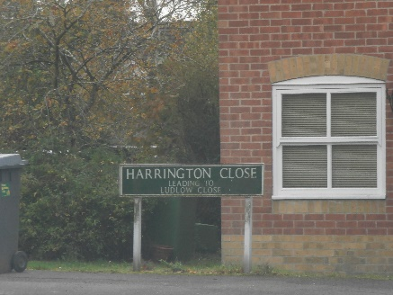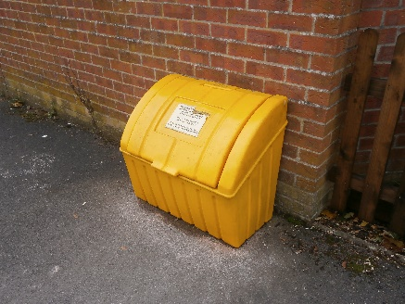 | WBC  ¾ full

 | Location of Grit Bin: | Owned By / Comments:
 | Ludlow Close, Newbury, RG14 2RH (No. 14)  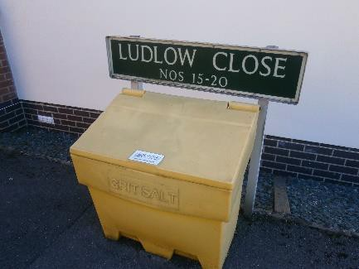 | NTC  Full
 | Overbecks / Junction of Gaywood Drive  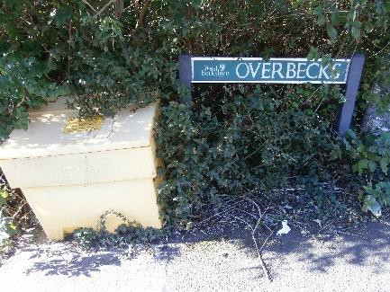 | NTC  Empty
 | Curling Way Junction of Gaywood Drive  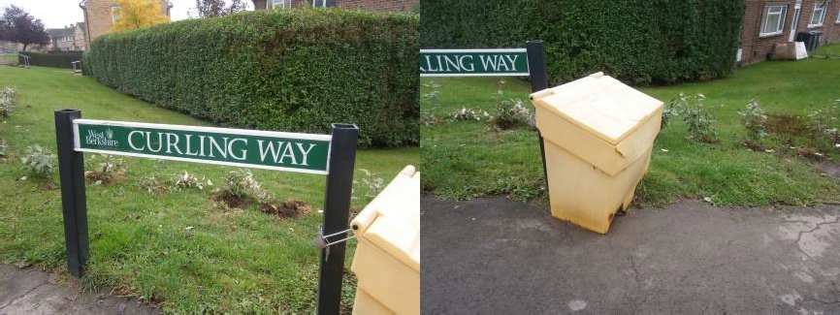 | NTC  Empty – remove rubbish and refill
 | Curling Way Junction of Rosemoor Gardens  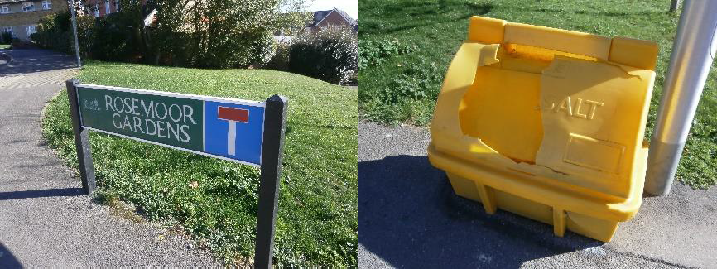 | WBC  ¼ full – Broken lid – Replace from NTC new stock held at Shaw and refill – dispose of damaged bin
 | Cherry Close Adjacent to 49  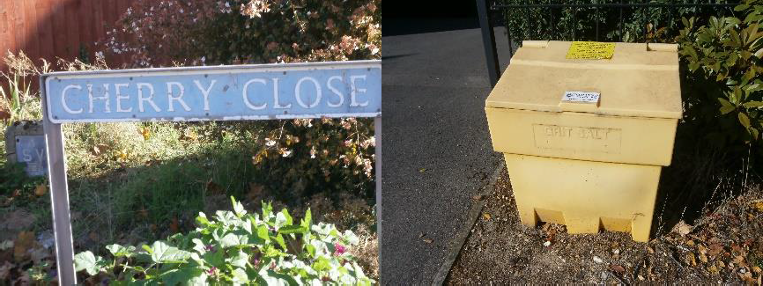 | NTC  ¼ full

 | Location of Grit Bin: | Owned By / Comments:
 | Digby Road, St. Leger Court, on NTC open space by carpark  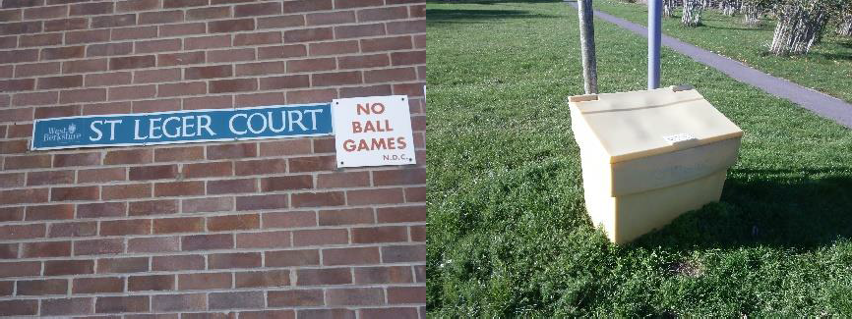 | NTC  ¼ full
 | Leys Gardens Junction of Old Bath Road  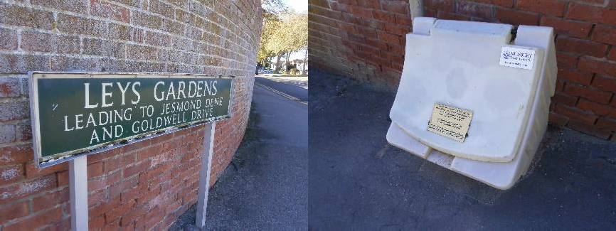 | NTC  Empty
 | Goldwell Drive, Newbury, RG14 2RH (No. 11)  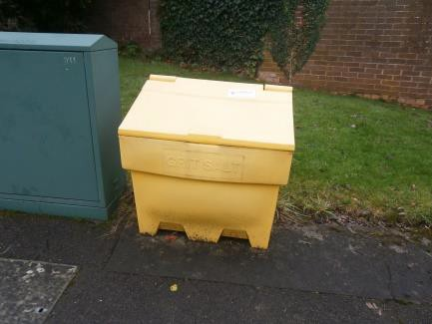 | NTC  ½ full
 | West Mills – Mallards Court  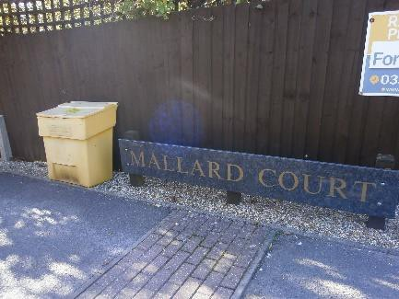 | NTC  ¼ full
 | West Mills by Swing bridge  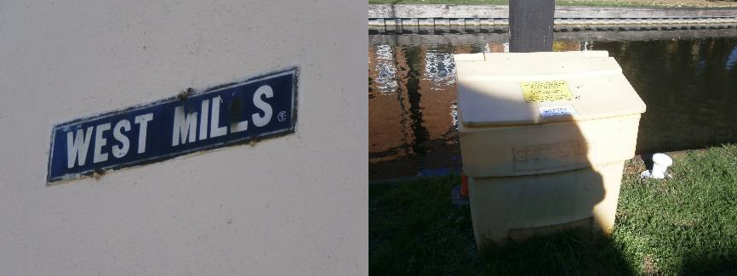 | NTC  ¼ full

 | Location of Grit Bin: | Owned By / Comments:
 | West Mills by St. Nicholas Church  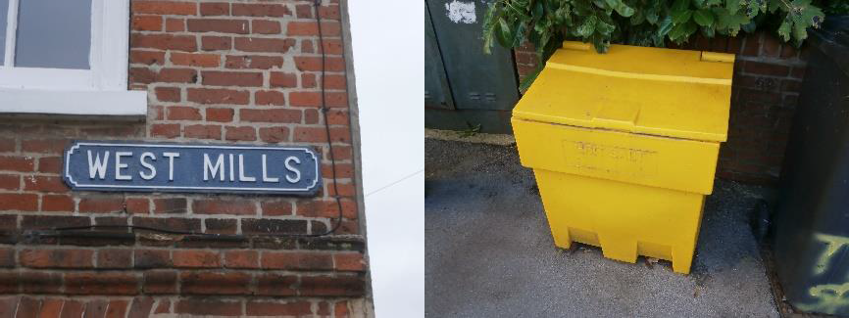 | NTC  ½ full
 | Corn Exchange rear of Alley Way – by Disabled drop off point  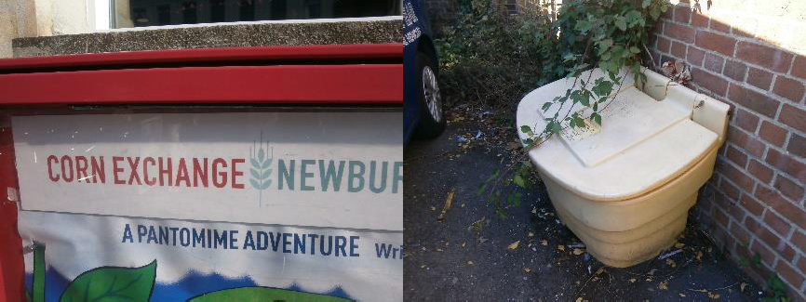 | NTC  ¾ full rubbish to be removed
 | Market Place, outside Town Hall  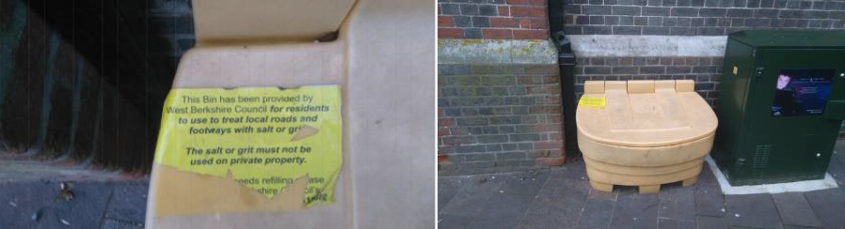 | WBC  Full

